Datos obligatorios para el registro de artículos científicos

Autor Principal
Nombres:
Apellidos:
Correo electrónico:
Afiliación (Institución):
Dirección de Institución:
Celular:
Coautor (es)
Autor Secundario 1
Nombres:
Apellidos:
Correo electrónico:
Afiliación (Institución):
Dirección de Institución:
Celular:
Autor Secundario 2
Nombres:
Apellidos:
Correo electrónico:
Afiliación (Institución):
Dirección de Institución:
Celular:
Autor Secundario 3
Nombres:
Apellidos:
Correo electrónico:
Afiliación (Institución):
Dirección de Institución:
Celular:

EXPERIMENTAL STUDY OF THE STRESS-STRAIN RELATIONSHIP OF SIMPLE AND FIBER-REINFORCED CONCRETE UNDER MONOTONIC LOAGIND

FirstName1 FAMILYNAME1 ^{1,2}, FirstName2 FAMILYNAME2 ²
¹ Civil Engineering Faculty, National University of Engineering, Lima, Peru.
² Japan-Peru Center for Earthquake Engineering Research and Disaster Mitigation, Lima, Peru.

Received: 23/01/2019 Accepted: 07/02/2019

ABSTRACT
All articles must contain an abstract. The abstract should give readers concise information about the content of the article and indicate the main results obtained and conclusions drawn. As the abstract is not part of the text it should be complete in itself; no table numbers, figure numbers, references or displayed mathematical expressions should be included. It should be suitable for direct inclusion in abstracting services and should not normally exceed 200 words. The abstract should generally be restricted to a single paragraph. These pages provide you with instructions on how to use this word template to prepare your paper according to the required layout and style for TECNIA papers.
Keywords: Please select a maximum of 5 keywords separated by commas.

- INTRODUCTION

The following template is for the use of Microsoft Word, nevertheless, any other text editor may be used to elaborate write the paper.

- FORMAT

The test must be within the margins in this present template; each column is 8.2 cm width and a gap of 0.6 cm between both columns, a total width of 17 cm and maximum length of 21 cm in the first page and 23.5 cm in the following pages
Title size font is 17pt, Authors is 13pt. All the text font must be Candara as follows: affiliation and address 8pt, Abstract 9pt, Keywords 8pt, Body text 10pt, Headers level 1, capital bold 10pt, Headers level 2, bold 10pt, Headers level 3, Italic 10pt, Footnotes page 8pt.

- HEADER (LEVEL 1)

  - Sub-Header 1 (Level 2)

    - Sub-Sub-Header 1 (Level 3)

- TABLES

Tables must have a title with 8pt size as is shown in Table 1.
Horizontal lines must be above and under table headers and sub-headers. Vertical lines must be avoided.
If a table is too large, table number and headers must be repeated in the next page before continuing the table.
A table can be displayed using the width of the column (see Table 1), or depending on the wide of the table, it can be display using the full width of the page (see Table 2).
All tables must be cross-referenced in the body text.

Table 1. Size and styles
Points | Place of Text | Style
10 | Number of table | Roman numerals
10 | Encabezados de figuras y tablas | ALL CAPS
8 | Figure and Table Captions Reference list | Small Caps

Table 2. Example
 | Planta Piloto |  |  | Planta a escala completa
 | Influent | Efluente |  | Influent | Effluent
Total cyanide | 6.5 | 0.35 |  | 2.0 | 0.30
Method-C cyanide | 4.1 | 0.05 |  |  | 0.02
Thiocyanide | 60.0 | 1.0 |  | 50.0 | <0.10
Amonio | 6.0 | 0.50 |  |  | 0.10
Cobre | 1.0 | 0.04 |  | 1.0 | 0.05
Solidos Suspendidos |  |  |  |  | <0.10

Table 3. Margins for A4 page size
Margins | A4
Upper | 2.5 cm
Down | 2.0 cm
Left | 2.0 cm
Right | 2.0 cm

- FIGURES

Graphics, charts and photos are considered as figures.
The letters and number size in the figure must be read clearly.
The title of the figure goes in the bottom part of the figure as is shown in Figure 1 (centered text and size font 8pt). If the figures were not made by yourself, please include the corresponding source of the figure.
Depending on the size of the figure, it can be place on a single column or using the full width of the page as is shown in Figure 2.
All figures must be cross-referenced in the body text.

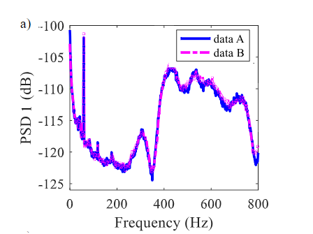
Figure 1. Los diversos elementos de una imagen deberán ser visibles sin esfuerzo. Para esto, sugerimos elegir tamaños de letras para los valores de los ejes y leyendas adecuados. (Source:xxxxx)

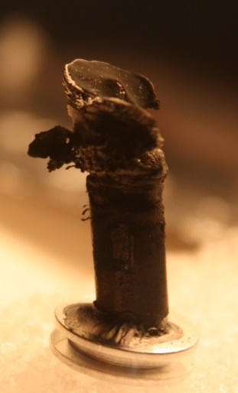 | 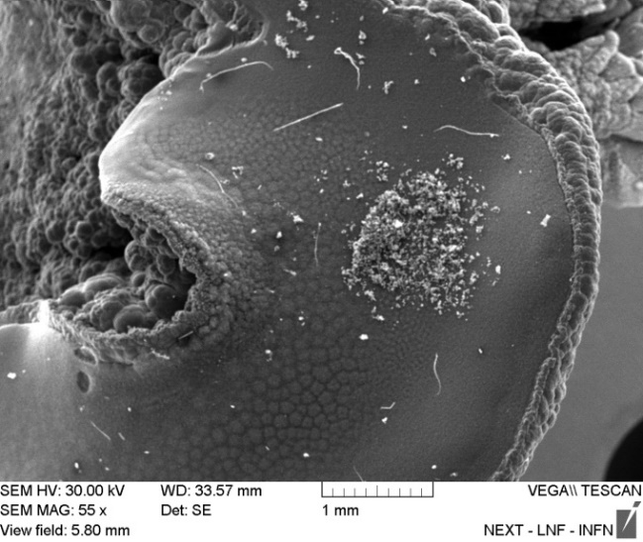
a) | b)
Figure 2. Ejemplos de imágenes a color: a) Foto de un cátodo después de la síntesis, b) Foto SEM de la superficie del cátodo. (Source: xxxxx)

- EQUATIONS

Equations must be placed aligned to the left and the corresponding numerical order aligned to the right as is shown in Eq. (1).

$A_{g}＝bd+(π-4)R^{2}$ | (1)

In case of too large equations, full width of the page can be used to display the equation, similar to the tables and figures cases.
Take into consideration that equation number must be aligned and centered with the equation.
All equations must be cross-referenced in the body text.

- APPENDIX

If needed, complementary information can be included in the Appendix of the article. For more than one appendix, Appendix A, Appendix B and etc. must be used.
In the appendix, tables, figures and equations must be numbered as follows respectively: Figure A.1, Table A.1 and Equation (A.1).

ACKNOWLEDGEMENT

Authors must include the acknowledgement to the collaborators, technical staff or the financial support received from an organization if apply. Acknowledgement is not a numbered section, and goes right after the last numbered section, commonly after Conclusions.

REFERENCES

References goes at the end of the article and must me numbered in the order that appears in the document. Reference numbering must be placed inside brackets []. Size reference font is 8pt.

Reference must include the following information:

- Family name and first letter of the given name;
- Publication date;
- Title of the publication, article, etc.;
- Title of the Journal, Book (optional);
- Volume;
- Editor;
- Place of publication;
- Page number.

For more detailed information about how to write the references, please follow Vancouver style system.

REFERENCE EXAMPLES

- Tallman D E, Wallace G G 1997 Synth. Met. 90 13
- Kroto H W, Fischer J E, Cox D E 1993 The Fullerenes Pergamon:Oxford
- MacDiarmid A G, Epstein A J 1991 in ed.W R Salaneck, D T Clark, E J Samuelson Science and Applications of Conducting Polymers Adam Hilger: Bristol p.117
- Eaton D I 1975 Porous glass support material US Patent No. 3 904
- Ziman J M 1979 Models of Disorder Cambridge Univ. Press: New York-London chapter 10
- Sze S M 1969 Physics of Semiconductor Devices Wiley Interscience: New York
- Shunin Yu N, Zhukovskii Yu F, Burlutskaya N Yu, Gopejenko V I, Bellucci S 2012 in Nanodevices and Nanomaterials for Ecological Security, Series: NATO Science for Peace Series B - Physics and Biophysics ed Yu Shunin and A Kiv Springer Verlag: Hiedelberg pp 237-262
- Sidorov S, Sidorova N G, Preobrazhenskii G I, et al. 1997 Vopr. Ikhtiol. 37 560 (1997 J. Ichthyol. 37, 547)
- Shunin Yu N, Zhukovskii Yu F, Gopejenko V I, Burlutskaya N, Lobanova-Shunina T and Bellucci S 2012 Journal of Nanophotonics 6(1), 061706-1-16

↑ If possible equalize columns on the last page ↑

Articles published by TECNIA can be shared through the Creative Commons license: CC BY 4.0 Peru. Permissions far from this scope can be consulted through the mail revistas@uni.edu.pe

Corresponding author: email@uni.edu.pe

